◈ dCollection Login Guide
- Thesis submission system(dCollection) Login Guide
- http://postech.dcollection.net/htmlView/loginGuide?localeParam=en / ID: Student ID Number
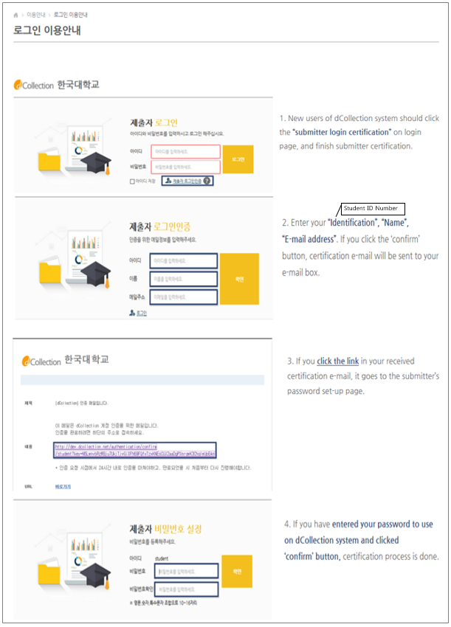
◈ Online Registration of the Electronic Copy
Graduate students who wish to graduate should submit their theses/dissertations according to the following guidelines
1. Login: Log in to the “Submit Theses” (POSTECH Library homepage ->Library Services -> Submit Theses.)
"Login(제출자로그인)" Click. The login ID is the Student ID number and the password is self-set.
After logging in, click the tab “ Submission”.
2. Dissertation submit: click the "Submit" button. (Read notice(공지사항) or click the "Online guide", it if necessary)
[If you read about online registration, you read notice or click the "Online guide" button. ]
(more information about online registration: read notice(공지사항) or click the "Online guide" button)
3. User Information: Confirm the personal information and update it if necessary.
4. Meta Information: Enter bibliographical information about the thesis, including the abstract and the table of contents.
5. License Agreement: Students are supposed to mark their choice as to whether they agree to the License Agreement. If agreed, the thesis will be converted into DRM PDF format and will be available for public access. If conditional agreed (They are going to publish on the journal, registration patent), they can modify “Full-text service start date Change”. If a student does not agree to the license agreement, He must enter the reason for disagreeing.
6. File uploading: Files in HWP, DOC, and PDF formats can be uploaded. If a file is too big to be uploaded (over 100 MB), save the file in a portable memory device (ex. CD) and submit it offline.
7. Final submission: Review the submission summary and change information, if necessary. After making sure that all the information is correct, click the “Submit” button.
8. Review submission: You can review the details about the submitted thesis, including the approval status.
9. Personal notice: If there was a problem in the thesis submission process, a return notice will be sent out by the administrator. If the submitted thesis has been approved by the administrator, an approval notice will be sent out by the administrator. The “License Agreement” can be printed out from the approval notice screen.
10. Submit the License Agreement (to be printed out at the end of the online registration process) along with hardbound copies(4 copies) of the thesis to the Tae-Joon Park Digital Library(Room no.204)
** Help & Contact : Yu, Dong-Hun(Tel.279-2546, E-mail), Library Room no.204.
◈ Dissertation Submission FAQ

The following guideline contains necessary information and frequently asked questions for the dissertation submission (hardbound copy & license agreement).
1. What is graduate thesis submission?
=> A student should turn in hardbound copies of dissertation and a license agreement for thesis submission. Four hardbound copies must be prepared for Master/Doctoral dissertation. The license agreement form is able to be printed after when the thesis’s electronic original document file is registered, converted, and approved online.

2. What is the license agreement about?
=> Agreeing to the license agreement allows the database construction without a change of content, and disclosure of original text to the information and communication network including internet. Thus it assents partial/whole transmission and reproduction of the literary properties. Please refer to the "Agreement to the Thesis info service (학위논문 원문제공 서비스에 대한 동의서[학위논문 기본저작 동의서])" on the ‘Copyright Agreement’ for detailed information.

3. When a patent application or Journal publication is pending, how should I change the license agreement?
=> A dissertation’s full-text public access date can be set after the patent application/journal publication. Choose ‘Agree’ on the license agreement procedure; then alter the public access schedule at ‘Full-text service Start date’. Conditional agreement (with setting the public access date) or disagreement blocks the internet search availability.
Accessibility to hardbound copies is also treated in the same terms (license agreement, conditional agreement, and disagreement) with the original text. Only licensed theses are enlisted in POSTECH library and presented at National Library*. Conditionally licensed theses are safeguarded separately until the public access date is exceeded. Browse, peruse, and presentation can be conducted after the previously set full-text service start date. Unlicensed theses are deposited and indexed only in POSTECH library; browse, peruse, and presentation to National Library are prohibited. *National Library : National Library of Korea, National Assembly Library

4. What is the type of license?
=> Copyright license type can be chosen among the Creative Commons Licenses (CCL), to give a degree of rights to people to share, use, and build upon the created work. License type setting is recommended to state the author’s right over the academic work and clarify the boundary of fair use. (Recommended setting: BY-NC-ND (Attribution – Noncommercial – No Derivatives))

5. How should the curriculum vitae (CV) be written?
=> Do not describe any specific personal information (date of birth, place of birth, contact number, address, etc.) on the CV in the end of the thesis. In the CV do not note personal information other than name, academic background and research activities to avoid privacy-related damages. If the CV on the hardbound copy already contains the personal information, remove the corresponding page.

6. How long does it take for a thesis to be registered, converted and approved?
=> Since the online registration, a thesis typically requires one day to be converted and approved by the administrator. In following cases, it may take exceptionally longer than usual.
- when too many theses are registered in a short time
- when conversion inspection takes a long time due to erroneously formatted theses
- when many theses are registered in nighttime/holidays (approval will be done in the following day)

7. How can I print the license agreement?
=> After logging in, a ‘License Agreement’ can be printed from the “Submission Details (제출내역)” menu at the right upper corner, when the thesis status is ‘Approved’.

8. How can I revise the submitted thesis?
=> Submitted theses can be revised only when the “Submission Detail” shows the status as ‘Unapproved’. When the thesis is ‘Approved’, contact the administrator.

** Help & Contact: Yu, Dong-Hun(Tel.279-2546, E-mail), Library Room no.204.

◈ Don’t describe personal information in CV

Don't describe other item to protect your personal information(birth date, birth place, telephone, email, address etc.) except name, education, and experience in Curriculum Vitae.

